1. SELECT RESERVATION_ID, RESERVATION.TRIP_ID, CUSTOMER.CUSTOMER_NUM, CUSTOMER.LAST_NAME

FROM RESERVATION, CUSTOMER

WHERE RESERVATION.CUSTOMER_NUM = CUSTOMER.CUSTOMER_NUM

ORDER BY CUSTOMER.LAST_NAME;

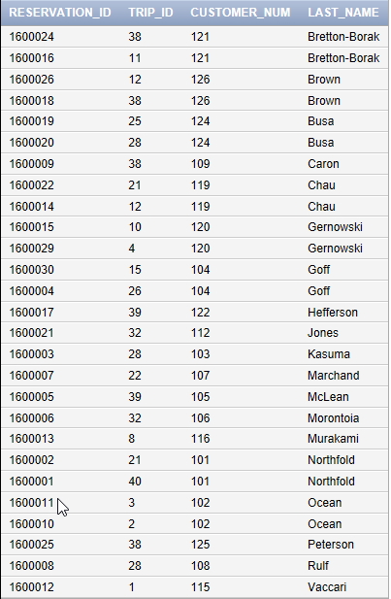

1. SELECT RESERVATION_ID, TRIP_ID, NUM_PERSONS

FROM RESERVATION, CUSTOMER

WHERE RESERVATION.CUSTOMER_NUM = CUSTOMER.CUSTOMER_NUM

AND CUSTOMER.LAST_NAME = ‘Goff’;

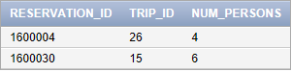

1. SELECT TRIP_NAME

FROM TRIP, GUIDE, TRIP_GUIDES

WHERE GUIDE.LAST_NAME = ‘Abrams’

AND GUIDE.FIRST_NAME = ‘Miles’

AND GUIDE.GUIDE_NUM = TRIP_GUIDES.GUIDE_NUM

AND TRIP_GUIDES.TRIP_ID = TRIP.TRIP_ID;

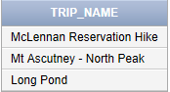

1. SELECT TRIP_NAME

FROM TRIP, GUIDE, TRIP_GUIDES

WHERE GUIDE.LAST_NAME = ‘Boyers’

AND GUIDE.FIRST_NAME = ‘Rita

AND GUIDE.GUIDE_NUM = TRIP_GUIDES.GUIDE_NUM

AND TRIP_GUIDES.TRIP_ID = TRIP.TRIP_ID

AND TRIP.TYPE = ‘Biking’;

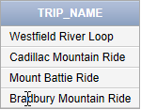

1. SELECT CUSTOMER.LAST_NAME, TRIP_NAME, START_LOCATION

FROM CUSTOMER, TRIP, RESERVATION

WHERE RESERVATION.TRIP_DATE = ‘7/23/2016’

AND RESERVATION.TRIP_ID = TRIP.TRIP_ID

AND RESERVATION.CUSTOMER_NUM = CUSTOMER.CUSTOMER_NUM;

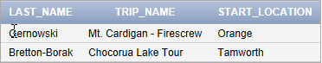

1. SELECT RESERVATION_ID, TRIP_ID, TRIP_DATE

FROM RESERVATION

WHERE TRIP_ID IN

(SELECT TRIP_ID

FROM TRIP

WHERE STATE = ‘ME’);

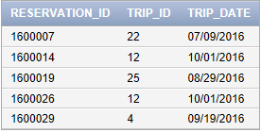

1. SELECT RESERVATION_ID, TRIP_ID, TRIP_DATE

FROM RESERVATION

WHERE EXISTS

(SELECT *

FROM TRIP

WHERE TRIP.TRIP_ID = RESERVATION

AND STATE = ‘ME’);

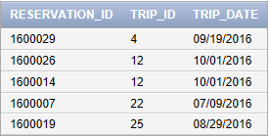

1. SELECT GUIDE.LAST_NAME, GUIDE.FIRST_NAME

FROM GUIDE, TRIP_GUIDES, TRIP

WHERE TRIP.TYPE = ‘Paddling’

AND TRIP.TRIP_ID = TRIP_GUIDES.TRIP_ID

AND TRIP_GUIDES.GUIDE_NUM = GUIDE.GUIDE_NUM;

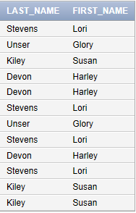

1. SELECT G.LAST_NAME, G.FIRST_NAME

FROM GUIDE G, TRIP_GUIDES TG, TRIP T

WHERE T.TYPE = ‘Paddling’

AND T.TRIP_ID = TG.TRIP_ID

AND TG.GUIDE_NUM = G.GUIDE_NUM;

REFER TO IMAGE ABOVE FOR RESULTS.

1. SELECT F.TRIP_ID, F.TRIP_NAME, S.TRIP_ID, S.TRIP_NAME, F.START_LOCATION

FROM TRIP F, TRIP S

WHERE F.START_LOCATION = S.START_LOCATION

AND F.TRIP_ID < S.TRIP_ID

ORDER BY F.START_LOCATION, S.START_LOCATION;

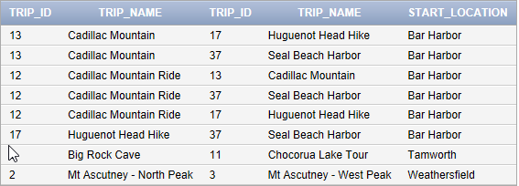

1. SELECT TRIP_NAME

FROM TRIP

WHERE TRIP_ID IN  
(SELECT TRIP_ID

FROM RESERVATION

WHERE TYPE = ‘Hiking’);

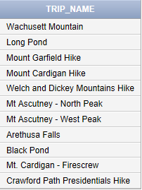

1. SELECT CUSTOMER_NUM, CUSTOMER.LAST_NAME, CUSTOMER.FIRST_NAME

FROM CUSTOMER

WHERE EXISTS

(SELECT *

FROM RESERVATION

WHERE CUSTOMER.CUSTOMER_NUM = RESERVATION.CUSTOMER_NUM

OR CUSTOMER.STATE = ‘NJ’);

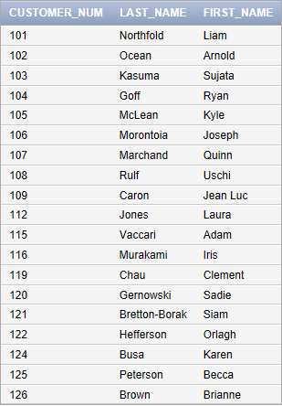

1. SELECT CUSTOMER_NUM, CUSTOMER.LAST_NAME, CUSTOMER.FIRST_NAME

FROM CUSTOMER

WHERE EXISTS

(SELECT *

FROM RESERVATION

WHERE CUSTOMER.CUSTOMER_NUM = RESERVATION.CUSTOMER_NUM

AND CUSTOMER.STATE = ‘NJ’);



1. SELECT TRIP_ID, TRIP_NAME

FROM TRIP

WHERE MAX_GRP_SIZE >

(SELECT MAX(MAX_GRP_SIZE)

FROM TRIP

WHERE TYPE = ‘Hiking’);



1. SELECT TRIP_ID, TRIP_NAME

FROM TRIP

WHERE MAX_GRP_SIZE > ANY

(SELECT MAX_GRP_SIZE

FROM TRIP

WHERE TYPE = ‘Hiking’);

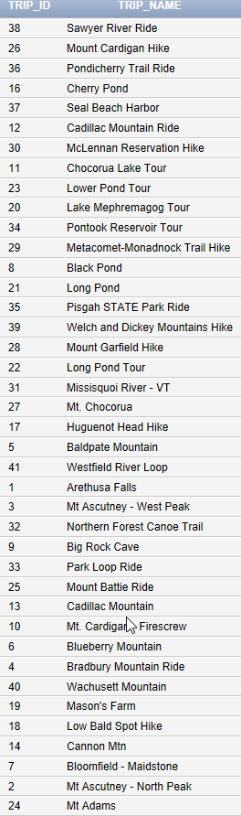

1. SELECT TRIP.TRIP_ID, TRIP_NAME, RESERVATION_ID

FROM TRIP

LEFT JOIN RESERVATION

ON TRIP.TRIP_ID = RESERVATION.TRIP_ID

ORDER BY TRIP_ID;

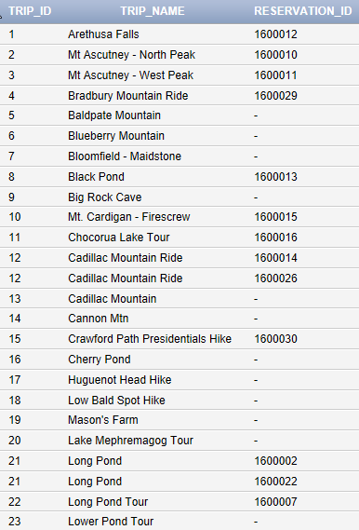

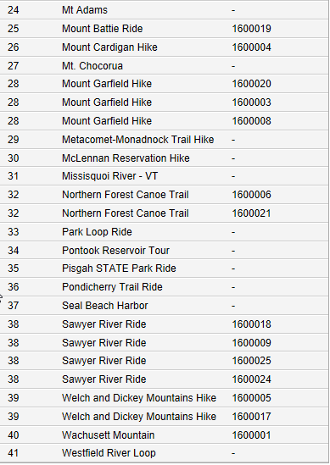

1. SELECT GUIDE.LAST_NAME, GUIDE.FIRST_NAME

FROM GUIDE

WHERE GUIDE_NUM IN

(SELECT GUIDE_NUM

FROM TRIP_GUIDES

WHERE TRIP_ID IN

(SELECT TRIP_ID

FROM TRIP

WHERE TYPE = ‘Paddling’));

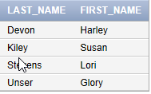

1. SELECT TRIP_NAME

FROM TRIP

WHERE STATE = ‘NH’

AND TYPE = ‘Hiking’

AND EXISTS

(SELECT *

FROM RESERVATION)

ORDER BY TRIP_NAME DESC;

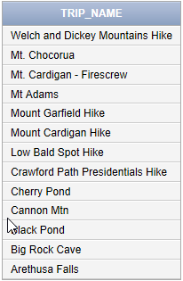SQP